

SYMBIOSIS INTERNATIONAL (DEEMED UNIVERSITY)
(Established under section 3 of the UGC Act 1956)
Re-accredited by NAAC with “A” Grade

Name of the Student: Sneha Sah PRN: 25070122189
Semester: 3 Year: AY 25-29

ASSIGNMENT No: 10
TITLE: Write a Java program to demonstrate the use of abstract classes and abstract methods.
Problem Statement: Write a Java program to demonstrate the use of abstract classes and abstract methods.

Theory: Abstract classes provide partial implementation of a program and cannot be instantiated directly. They may contain both abstract and concrete methods. Abstract methods declare functionality that must be implemented by subclasses. Abstraction hides implementation details while exposing only essential functionality. This improves code flexibility and maintainability in object-oriented programming.

Exercise 1.
Create an abstract Payment class and implement Credit Card and UPI payment classes.?

Source code:

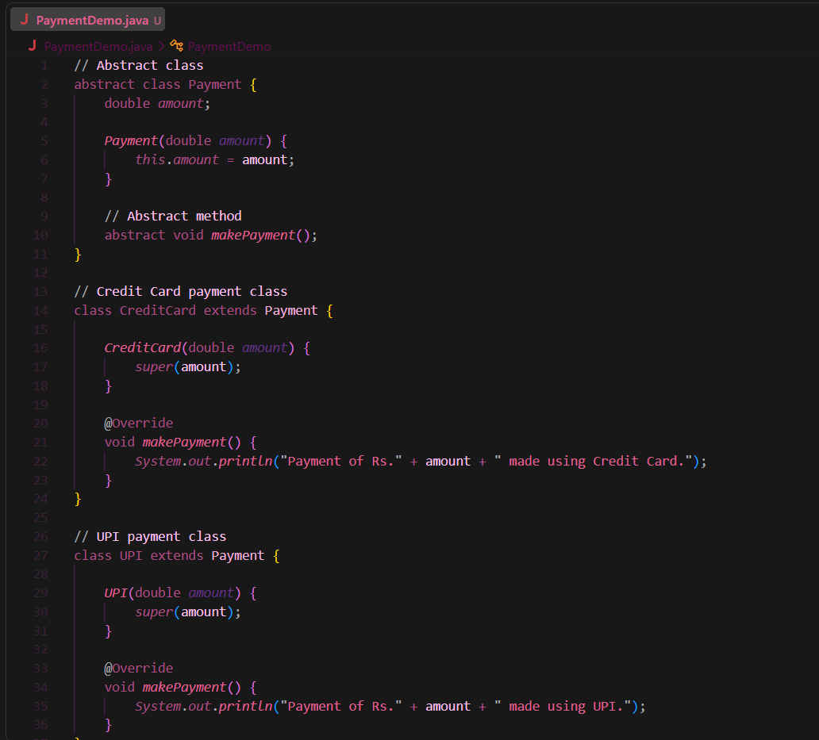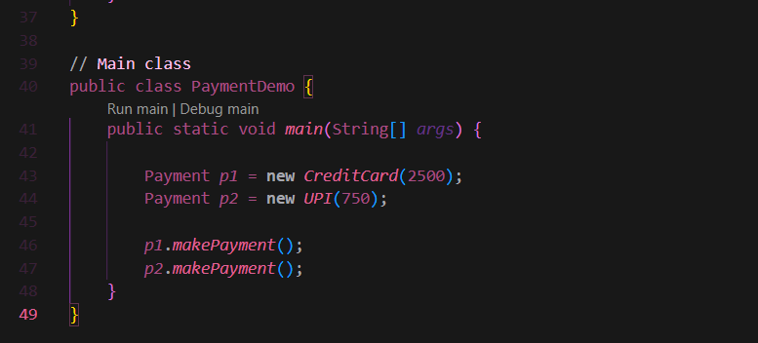
Output:
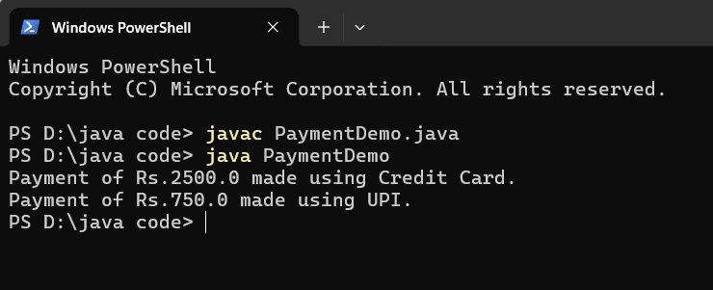
2. Create an abstract FoodOrder class with an abstract method calculateBill(). Implement two subclasses, DineInOrder and TakeAwayOrder, to calculate and display the total bill based on the order type.
Source code:
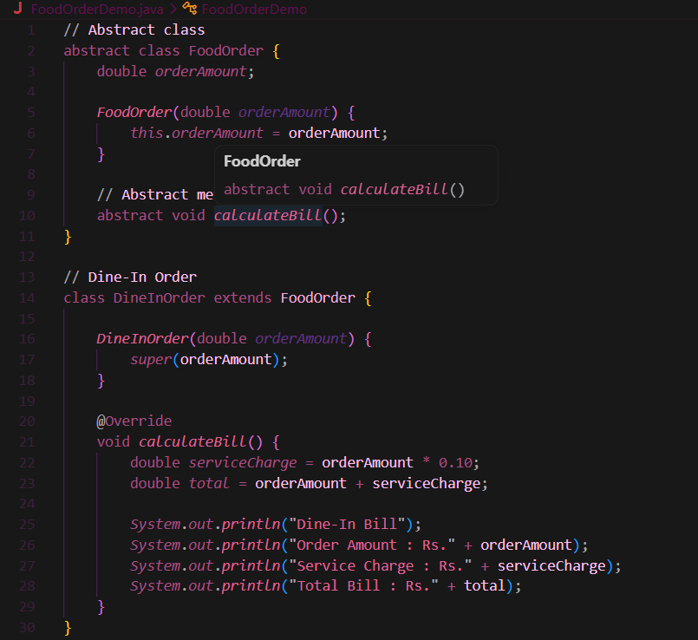
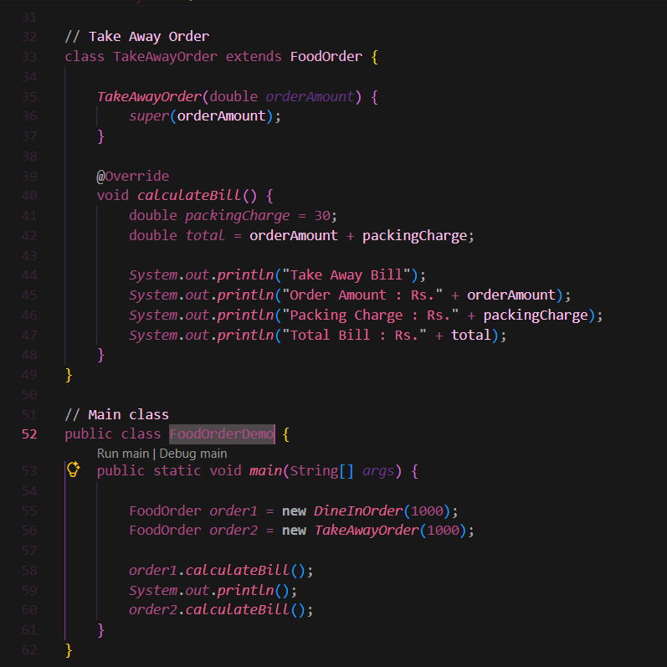

Output:
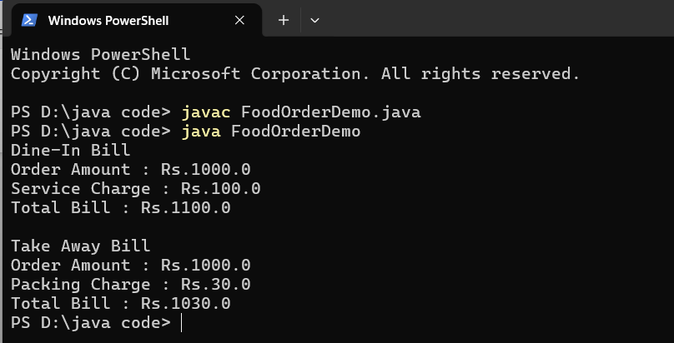

Conclusion:
This experiment demonstrates the use of abstract classes and abstract methods in Java. The Payment abstract class defines a common method, makePayment(), which is implemented differently by the CreditCard and UPI subclasses. This shows how abstraction hides implementation details while allowing different classes to provide their own behavior, improving code reusability, flexibility, and maintainability.

